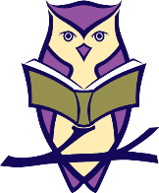
St Neots Tuition
Punctuation Printables

Now check your answers!
I like ham and eggs.
Do you like ham and eggs?
My dog is black and brown.
What colour is your dog?
Can you play in the park?
Is it time to go home?
My mum said it is time to go home.
Do you have a cat?
A baby can play with a toy.
Can a baby play with a toy?
Did you go to school today?
I went to school today.

