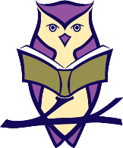
St Neots Tuition
Punctuation Printables

Now check your answers!
I like to read a good book.
The girl is in the big car.
When can we go to the shops?
Will we be in time for school?
We can have a drink.
The boy is on top of the rock.
Have you got my sock?
Can you see my sock?
My sock is in the bin.
The cat is on the mat in the sun.
Is the dog on the mat too?
Where is the black dog?

