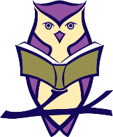
St Neots Tuition
Punctuation Printables

Question mark or full stop? Don’t forget the capital letters!

i like to read a good book
the girl is in the big car
when can we go to the shops
will we be in time for school
we can have a drink
the boy is on top of the rock
have you got my sock
can you see my sock
my sock is in the bin
the cat is on the mat in the sun
is the dog on the mat too
where is the black dog

